**INTERSHIP REPORT**

**HIGHRADIUS TECHNOLOGIES**

*Submitted by*

**Akshat Pareta**

**20BCS6567**



*in partial fulfillment of Summer training for the award of the degree*

*of*

BACHELOR OF ENGINEERING

IN

CSE Specialization in AIML

APEX INSTITUTE OF TECHNOLOGY

CHANDIGARH UNIVERSITY, GHARUAN

Mohali, Punjab

8TH SEMESTER, 4TH YEAR

## TABLE OF CONTENT

|  |  |  |
| --- | --- | --- |
| **S. No.** | **Title** | **Page** |
| 1 | DECLARATION BY STUDENT | 2 |
| 2 | INTERNSHIP OFFERLETTER CERTIFICATE | 7 |
| 3 | DECLARATION BY SUPERVISOR | 3 |
| 4 | List of Figures  1.1-brief history of company 2.1- Phases of the project   * 1. - Main Worklist Screen   2. – Administration screen   3. – Deductions Configurations   4. – Schedule Agents screen   5. – Project Methodology   6. Performance Measurement metrics |  |
| 5 | INTRODUCTION OF THE COMPANY | 8-9 |
| 6 | INTRODUCTION OF THE PROJECT UNDERTAKEN | 10-15 |
| 7 | BRIEF ABOUT THE PROJECT DONE | 16-21 |
| 8 | CHALLENGES FACED & TACKLED | 21 |
| 9 | PERFORMANCE METRICS | 22-24 |
| 10 | LEARNING OUTCOMES | 25 |

# INTRODUCTION OF THE COMPANY

## Company’s Vision and Mission :

HighRadius offers cloud-based [Autonomous Software](https://www.highradius.com/autonomous/) for the Office of the CFO. More than 700 of the world’s leading companies have transformed their order to cash, treasury and record to report processes with HighRadius. Our customers include 3M, Unilever, Anheuser-Busch InBev, Sanofi, Kellogg Company, Danone, Hershey’s and many more.

## Origin and Growth of The Company :

This company was founded in 2006 by Sushi Narahari (Co-founder) in Hyderabad, India. Despite a challenging 2020, HighRadius registered a 47% growth in Contracted ARR (Annual Recurring Revenue) compared to the previous year. As of today, HighRadius has grown to 600 customers, including over 200 customers from Forbes Global 2000.Presently highradius has 4000-5000 Employees.

## Various Departments And Their Functions :

* *Product and Engineering*: This is the technical wing of the company. It is responsible for all technical aspects which include Product development, Maintenance, Research and Development etc.
* *Consulting* - This is the business department of the company whose roles are. understand current business processes for clients, analyze potential solutions to business problems, be a trusted domain consultant for our clients Configure the product to meet business needs Deliver business benefits like streamlined processes.
* Sales and Marketing: - This is the business department of the company whose roles are Product demonstration to Business Divisions of Fortune 1000 companies (CXO/VP/Director level audience), Requirement Elicitation and Customer Qualification via a Systematic Analysis of Customer Business, Creating and implementing Go To Market Strategies Building targeted content pipeline including eBooks, journals, articles, blogs, infographics, newsletters, and webinars
* *People and Culture*: This is the employment management department which works in employment performance analysis, recruitment etc.

**Organization Chart of The Company**

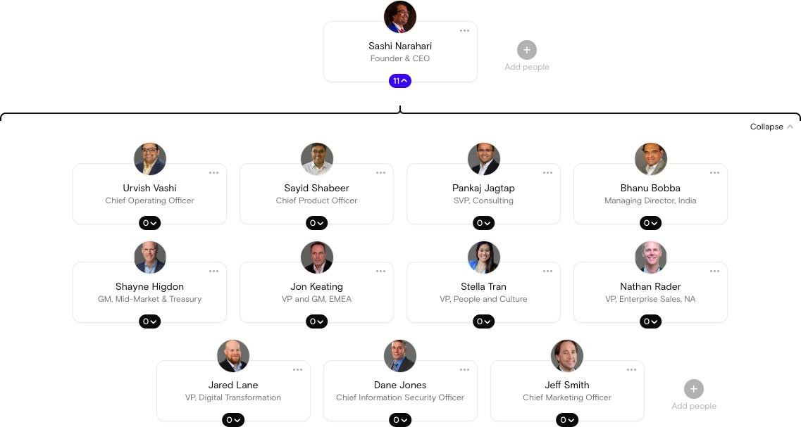

# INTRODUCTION OF THE PROJECT UNDERTAKEN

## Objectives of The Work Undertaken :

* Understand current business processes for clients.
* Analyze potential solutions to business problems.
* Be a trusted domain consultant for our clients Configure the product to meet business needs.
* Deliver business benefits like streamlined processes, ROI, Product Pricing
* Ensure business efficiency increases through their knowledge of both IT and business function.

## Importance and Applicability :

A Consultant’s requirements analyze the operation processes and share business insights. The primary role of a data analyst is to relate data to decisions to improve the productivity and efficiency of the business either to give maximum automation in terms of preparing client systems or test different types of solutions to provide maximum solutions.

#### **Roles and Profile :**

* ***DMS Consultant Trainee***

**Brief Description of The Work Done**

#### **Position of Internship and Roles :**

DMS Consultant Trainee **-** Understand current business processes for clients, analyze potential solutions to business problems, be a trusted domain consultant for our clients Configure the product to meet business needs Deliver business benefits like streamlined processes. Make PPTs based on root cause analysis, data analysis and business intelligence.

#### **Activities/ Equipment Handled :**

Activities - Performed a team volunteer for the evolution of all the interns and planned a systematic workflow for 2 weeks.

Equipment handled – Excel, Spreadsheets, Google Docs and Business solutions Frameworks, Product Training etc.

#### **Challenges faced and how those were tackled :**

Analyzing the data created several miss-leads while categorizing the data for the company - this problem was solved by learning the Q- Matrix framework which mainly divided the problem into 4 parts depending upon the value they add to the company.

## INTRODUCTION OF THE COMPANY

* **Highradius** was founded in 2006 by Shashi Narahari.
* Highradius is a cloud based fin tech SAAS company.
* The solution helps businesses improve their cash flow and reduce the time required to resolve outstanding invoices.
* Highradius software is used by 800 world leading companies like **Unilever, Hershey**, **McCormick, Pepsi Co, Kellogg** etc.
* Highradius’s target market is large - mid-sized businesses across all industries.
* Highradius Became a **Unicorn (HighRadius achieved a valuation of over $1 billion)** in 2020 & became a **centaur** in 2023 (Centaur is a SaaS business that has $100M+ of Annual Recurring Revenue and is 7x rarer than Unicorn.)
* Highradius is the Forbes Cloud 100 list company.
* Highradius solutions deliver increased operational efficiency through Automation , Accurate Flow Forecasting, Optimized cash management , lower Days sales outstanding to help companies achieve strong ROI.
* **Global Headquarters** for Highradius is in **Houston, Texas, United States.**
* Highradius also have offices across the globe. London, Amsterdam, Poland, Frankfurt, Paris.
* Here is the Journey of the Highradius in the following (figure 1.1)

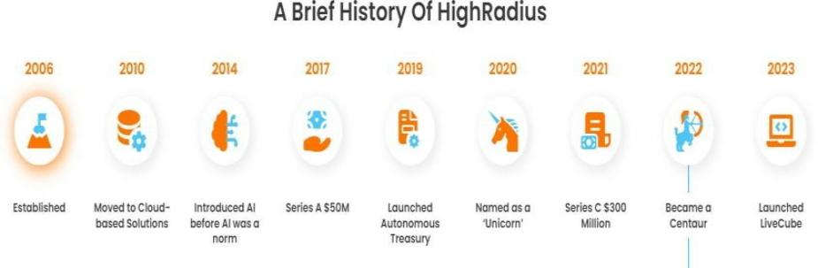

Figure 1.1

**Here are some core values of the Highradius: -**

***Let the best idea win.***

***Be Bold & Blunt***

***Hop on the roller Coaster.***

***Ride or die with the Customer.***

***Call BS on your Boss***

***Go gritty or Go Home***

***Be Humble & ready to rumble.***

***Bring the Zing***

## INTRODUCTION OF THE PROJECT UNDERTAKEN

McCain Foods was co-founded in 1957 by brothers [Harrison McCain](https://en.wikipedia.org/wiki/Harrison_McCain) and [Wallace](https://en.wikipedia.org/wiki/Wallace_McCain) [McCain](https://en.wikipedia.org/wiki/Wallace_McCain) with the help of their two older brothers.

In their first year of production, the company hired 30 employees and grossed over $150,000 in sales. During the 1970s–1990s, the company expanded into additional prepared food markets including frozen pizza and vegetables.

**Work in the project**: -

Basically, we have certain phases for the project which is shown in the figure (2.1)

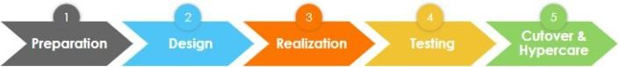

### Figure (2.1) – Phases of project

As my current project is in the Hypercare phase, I get to work on the issues and resolve the issues which are faced by the clients during testing & after testing of the product.

Basically, we used SQL as a source for the backend, most of the work and issues can be resolved through the backend by finding the logic & root cause of the issue.

I get to work on multiple projects like PepsiCo, Kellogg, McCormick (Validation part).

I got to know how the issues would be related to my product (DMS) & got to know how to communicate effectively through clients and understanding their issues etc.

Steps i take to resolve the issue: -

1. Firstly, I go through the problem statement with the help of my Senior.
2. I will be checking the previous records to see if there is any issue that was raised previously.
3. I go through the DB through some SQL queries and get to know where the problem is happening.
4. If yes, we take the logs of UI that were taken to the Technical consulting team which helps to resolve the issue through the logs files.
5. They give the resolution to resolve & we would try to resolve according to the suggestions & RCA given by the TC team.
6. Logs are basically a set of files which have all the lines of code where we get to troubleshoot the problem.

## Business Terminologies

### **The commonly used terms are:**

* **Client**: Client or Account is the company that buys and uses our product. Example- Hershey’s, P&G etc.
* **Customer**: Client's end-customers. The companies that actually make Payments to our Clients HighRadius Client's end-customers will be called customers. Example- Walmart, K-mart etc.
* **POD & BOL**- Proof of delivery (POD) is a method to establish the fact that the recipient received the contents sent by the sender. A bill of lading is a document issued by a carrier (or his agent) to acknowledge receipt of cargo for shipment. These documents are mostly found on web portals.
* **Claims** – These are the documents containing the list of items that they want a refund or rebate on. The reason maybe delivering wrong product, damage or any other reason. And these documents contain quantity, unit price and reference field for each line item.
* **Credit**: Credit is the trust maintained between a customer and client on the basis that a customer will make the payment for the purchase of goods or services at a future date.
* **Invoice:** A receipt of acknowledgement for the goods or services provided and their respective cost. The customer receives an invoice from the client specifying the goods dispatched or soled and the cost associated with the purchase.

## Business Flow

**Implementation Timeline for a particular project: -**

|  |  |
| --- | --- |
| **Estimated Timelines** | |
| **Phases** | **Number of Weeks** |
| Blueprint/Design Sprint | 3 |
| Realization/Build | 6 |
| Testing | 3 |
| Training/Cutover/Go-Live | 3 |
| Hypercare | 3 |
| **Total # of Weeks** | **18** |

## Implementation Methodology

* HighRadius’ implementation methodology comprises of five main stages (Preparation, Blueprint, Realization, Test, cut over and Go-Live) tailored individually to meet the specific implementation and resource needs of Customer.
* These stages ensure that each part of the project is given the appropriate level of attention to guarantee successful implementation – on time and within budget.
* We use the agile philosophy and run the phases in 3-week sprints.

## Project Preparation & Data Collection

* The objective of the preparation phase is to get a preliminary understanding of the business process in place of a customer.
* This would require the Customer to complete a set of questionnaires and worksheets provided by High Radius.
* Additionally, an open deductions report and a one-year history of all deductions created in the system is required.

## Blueprint

Through a series of workshops with key stakeholders, HRC will analyze business needs and challenges, and gather requirements that will illustrate the value-added functionality that Deductions Cloud will deliver. Following key activities will be performed during this phase:

* Process overview & scope alignment
* Understand the current AS-IS process.
* Understand the current customer master and item master hierarchy.
* Understand the ERP system configuration and data mapping rules.
* Identify the future state design and prepare a process design document.

## Realization

As part of the realization process, HRC and the Customer will build and configure the different systems to ensure business requirements are met as per the future state design. The following tasks are performed during this phase.

* Develop functional specification to address data mapping between
* Customer’s ERP (SAP) and HRC’s Deductions Cloud system.
* Configure owner processor rules to enable workflow-based routing of deductions.
* Enable out-of-the box reports and build correspondence packages.
* Unit testing and validation.
* Develop integration test scripts.

## Testing(UAT)

* There will be 3 cycles of testing, of which 2 are Integration test cycles and one User Acceptance Test (UAT).
* These cycles are conducted to ensure that the delivered product performs consistently and meets all requirements.
* During this stage, the business users at the Customer’s organization will validate the functionality designed and developed.

## Cut over – Go live

* Highradius will develop a cutover checklist that lists out all the tasks that need to be performed by different teams for a successful “Go Live”.
* Highradius will carry out final checks on the system such as ensuring consistency and system performance before going live.
* Highradius will also train and provide knowledge transfer to ensure the success of the Deduction management solution.

## Hypercare

* Provide post-go-live support for stabilization and continuity.
* Providing the resolutions for the issues they are facing for a certain period of time based on the Agreement.



## Deductions Management System Process

**Create deductions from Open A/R data:**

* System creates Deduction entities from the Open A/R data that flows in through the Open A/R interface.
* A deduction entity has several standard attributes like reason code, status, owner, amount, priority etc.
* The system also provides a flexibility to define other deduction attributes that are specific to a business and not included in the standard list.

**Proactively create deductions from customer claims :**

* Use customer claims from customer portals to proactively log deductions and allow the analysts to research the validity of the deduction even before the customer takes a deduction.
* This essentially cuts down the DDO KPI.

**Link deduction back up to Deduction :**

* The system would automatically link all aggregated deduction backups that are not limited to claim, POD, Deal sheets, remittance, and check images onto the deduction entity.

**Link other entities to Deduction: -**

* System would automatically link entities like claims, credits and sales invoice if any to the deductions.
* This would help the analyst to effectively do the research on that deduction entity as it has all the necessary information in one place.

## Brief Description of the Project Done:

**Position/internship role: -**

* Associate consultant intern

## Activities Accomplished

* Supported the project in the last phase (Hypercare)
* Helped in resolving the issues which are faced by the clients.
* Cross validations from the test environment to production environment.
* Got to attend the Hypercare calls with the McCain clients and got to know about the types of issues they are facing.
* Daily updates & scrum calls.
* Used Jira to raise a ticket for the issues.
* We used different tools of Highradius (bouncer, slog, putty etc.,).
* Bouncer is used to take access to the accounts & to make any updates in the database we insert the queries, and we send it for approval.

## Implementation Framework

* It is the first model which is introduced in IT marketing.
* It is also known as sequential or linear life cycle model.
* In this model previous phase output is given as input to next phase output.
* In this model each phase must be completed before next phase begin.
* In this model phases do not overlap.
* Main aim of waterfall model is to develop a new software followed step by step when customer requirements are clear.

**Advantages :**

* Simple and easy to understand.
* Phases are processed and completed one at a time.
* Works well for smaller projects where requirements are very well understood

## Disadvantages:

* Testing activities should start once the application is integrated.
* Sudden changes of requirements are not allowed.
* Not a good model for complex and object-oriented projects.
* Poor model for long projects due to high amounts of risk and uncertainly.

**Project Methodology pictorial representation is show in the figure (3.1)**

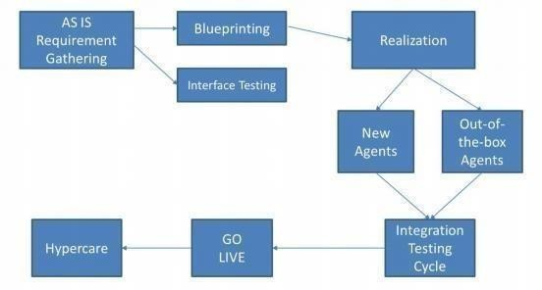Figure 3.1 – Project Methodology

Ideally, the **Preparation** phase should start 2-4 weeks before planning to conduct the Blueprinting workshop.

During this phase, Project is started by taking the Client’s data and the data is analyzed. The idea is to build rules/agents to get as much automation as possible.

It helps a lot to know client's data as much as possible before Blueprint starts, especially remit formats, know little bit about client's customer.

At the end of **AS-IS**, workload analysis is done - one of our objectives is to increase productivity of client's team.

So, as part of workload analysis, we quantify where the client is spending the most time and identify the highest opportunities to help it reduce the manual effort.

After Blueprint is the Realization Phase. In this Phase

* Product Definition Document should be available and clear before starting this phase.
* Any ambiguities should be clarified before entering the next phase.
* The agents are then categorized into two categories-
* **Testing -1** where simulation of 1 days’ worth of data is done. Ultimately, the objective is to simulate what happens in production.
* It won’t be exact but try to set-up a simulation scenario which is close enough.
* So, just to clarify, this simulation is different from simulation analysis.
* **Simulation** is done and issues are fixed if any. Then, through cycle different data- set or again the same dataset.
* That’s a decision to be taken during the realization phase.
* So, by the time of cycle 2, most of the fixes are done as we have run through 5 days’ worth of data and identified the issues.
* So, cycle 2 should be much smoother.
* Then by the 4th week, once all fixes are done, we get into User Acceptance Testing (UAT).
* And then, at end of UAT, client will have to do a go/no-go decision– you are the client, you will decide given what you have seen in system is in-line with what it wanted.
* User training is also taken up during the testing phase. The last phase of the project is Cut-over and go-live, which will happen over one week’s period.
* Right after UAT, preparation for production is started, and cutover activities and go-live is initiated.

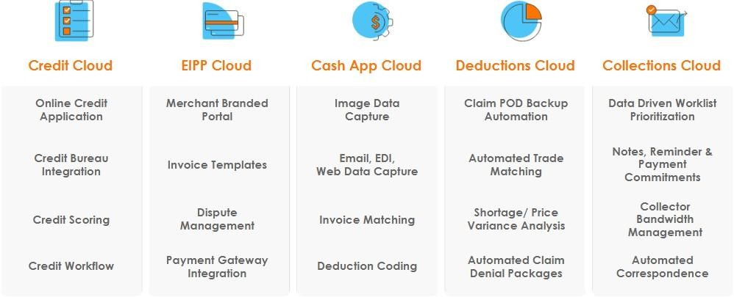Starting from requirement gathering and analysis to go live in the production phase, the end-to- end implementation of the DMS product is the sole scope of this project.

**Challenges faced and how those were tackled: - (MQRReport issue.)**

**Steps i take to resolve the issue :**

* Firstly, I go through the problem statement with the help of my Senior Consultant.
* I will be checking the previous records to see if there is any issue that was raised previously.
* We also verify that this is the issue which is faced in the test environment or in the production environment only.
* I go through the DB through some SQL queries and get to know where the problem is happening.
* If yes, we take the logs of UI that were taken to the technical consulting team which helps to resolve the issue through the logs files.
* They give the resolution to resolve & we would try to resolve according to the suggestions & RCA given by the TC team.
* Logs are basically a file which has all the lines of code where we get to troubleshoot the problem.

## Performance Measurement Metrics

At Highradius, there are three key performance Indicators known as TQVs-

1. Time
2. Quality
3. Value

* **Time** refers to the total time given for the project. The efforts are always to keep it minimized. For now, it is 12 weeks minimum and 15 weeks on average.
* **Quality** refers to the level of automation we provide on Cash Application. It is taken care that the percentage of automation remains 90% and above until and unless there are some genuine issues with the Client’s way of handling payments.
* **Value** refers to the ROI that the client gets for collaborating with Highradius.
* Whether the Deductions Management cloud was able to meet the Client’s Expectations and Business Requirement.
* It is about the delivery of results.

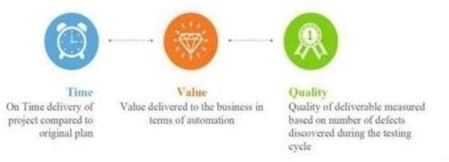

Figure 3.6 Performance Measurement metrics

## Agile and Scrum model

* It is continuous iterations of development and testing throughout the software development cycle of the project.
* Iterations is defined as a small release of a software.
* Agile testing starts at the beginning of the project with rapid integration between development and testing.
* We can define the term “agile” as “moving quickly and easily.
* In agile testing testers are closely working with the development team and testing are done in parallel as when a piece of code has been developed.
* Agile testing is a team effort. We can achieve quality and success by working as a single team.

## Advantages of Agile model:

* Is a very realistic approach to software development.
* Promotes teamwork and cross training.
* Suitable for fixed or changing requirements.
* Easy to manage.

## Disadvantages of Agile model:

* Not suitable for handling complex dependencies.
* An overall plan, an agile leader and agile PM practice is a must without which it will not work.
* Depends heavily on customer interaction, so if customer is not clear, team can be driven in the wrong direction.

## Scrum Methodology:

* Scrum is an agile process which focuses on highest priorities and can deliver a working software in shortest duration.
* In scrum methodology we have small teams.
* In this methodology scrum master (SM), product owner (PO), scrum team, stake holders are present.
* Scrum master is responsible for settingup the team, sprint meeting and removing obstacles to progress.
* Product owner creates product backlog, prioritizes the backlog and is responsible for the delivery of the functionality at each iteration.
* Scrum team manages its own work and organizes the work to complete the sprint or cycle.

**The most difficult situation I encountered during this month of internship :**

* Well, when I am working on the correspondence templates few of the dynamic field’s data were not populating.
* The second issue was in the correspondence templates at single level the second entry was not populating in the table.
* To resolve this issue, I have raised a ticket to the TC team.
* They came back with a solution explaining how to resolve it.

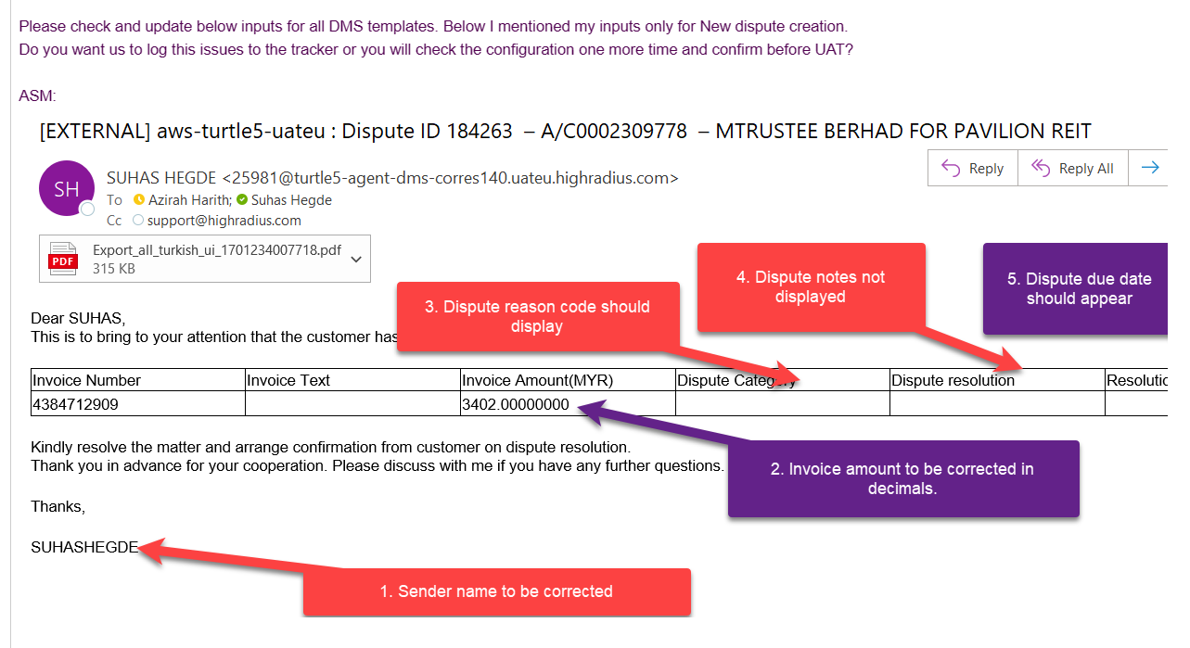

## Learning Outcomes

1. I learned about the importance of SQL and other logic operators which are used for the database.
2. I learned the importance of communication which helps to keep the ideas to the point and to narrate the ideas which we have.
3. I learned the different tools which are used by Highradius (Bouncer, Genie, SQL Yog, putty, UI etc. (Turtle & cloud)
4. I learned about the Cybersecurity threats which commonly every organization faces.
5. I learned how to collaborate with the different departments of the organization like TC team, IT team, Product Team, Db team, analytics team, RMG team, Hr team etc.
6. I learned about the different phases of the project and how it is handled to get a successful outcome.
7. I learned about the different configurations used in the UI which are included in the design sheet to deliver as is.
8. I came to know about the different products which high radius have for different business needs.